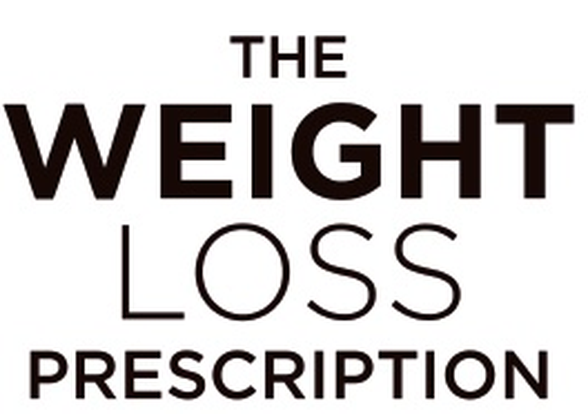
SESSION 11 | Maintenance Planning
Ready to Reduce My Dose?
Purpose: This worksheet helps you assess whether you might be ready to reduce your medication dose or move to a maintenance level. There is no rush. Complete this with your prescriber.
Where Am I Now?
How long have I been at or near my target weight? _______________________
How stable has my weight been over the past 3 months? _______________________
Current medication and dose: _______________________
Lifestyle Foundations
(tick those firmly established)
☐ Regular eating patterns ☐ Hunger and fullness awareness ☐ Emotional eating strategies
☐ Regular physical activity ☐ Good sleep habits ☐ Stress management techniques
Why Am I Considering Reducing My Dose?
What Concerns Do I Have About Reducing?
What Support Do I Have in Place?
My Decision (discuss with prescriber)
☐ Continue on current dose for now ☐ Try a reduced dose ☐ Need more time to decide

Next review date: _______________________

