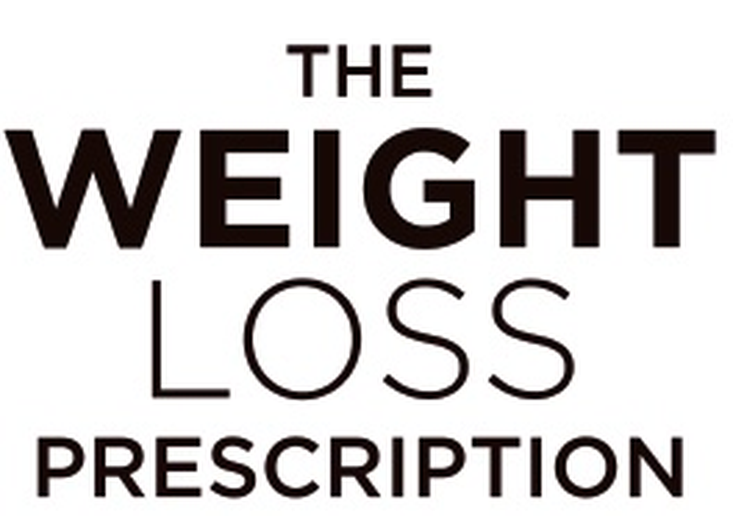
SESSION 11 | Your Early Warning System
Traffic Light Assessment
Use this assessment monthly, or whenever you’re uncertain where you are. Your score tells you which zone you’re in and what action to take.

Date:

Rate each item 1–10 | Score
THOUGHTS:  I’m thinking positively about myself | /10
THOUGHTS:  I’m not obsessing about food or weight | /10
THOUGHTS:  I can challenge negative self-talk | /10
THOUGHTS:  I feel hopeful about the future | /10
THOUGHTS:  My inner critic is manageable | /10
EMOTIONS:  My mood is generally stable | /10
EMOTIONS:  I can cope with difficult feelings | /10
EMOTIONS:  I’m not using food to manage emotions | /10
EMOTIONS:  I feel connected to others | /10
EMOTIONS:  I have moments of joy or contentment | /10
BEHAVIOURS:  I’m eating regular meals | /10
BEHAVIOURS:  I’m using hunger/fullness cues | /10
BEHAVIOURS:  I’m moving my body in ways I enjoy | /10
BEHAVIOURS:  I’m sleeping adequately | /10
BEHAVIOURS:  I’m maintaining social connections | /10
PHYSICAL:  My energy levels are good | /10
PHYSICAL:  I’m not experiencing unusual fatigue | /10
PHYSICAL:  My digestion feels normal | /10
PHYSICAL:  I’m staying hydrated | /10
PHYSICAL:  I feel physically comfortable | /10

TOTAL SCORE: _______ /200 MY ZONE: ☐ GREEN ☐ AMBER ☐ RED

GREEN (160–200): Continue what you’re doing. Monthly check-ins are sufficient.
AMBER (120–159): Go to your Amber Action Plan and implement it this week.
RED (Below 120): Go to your Red Emergency Protocol today.

