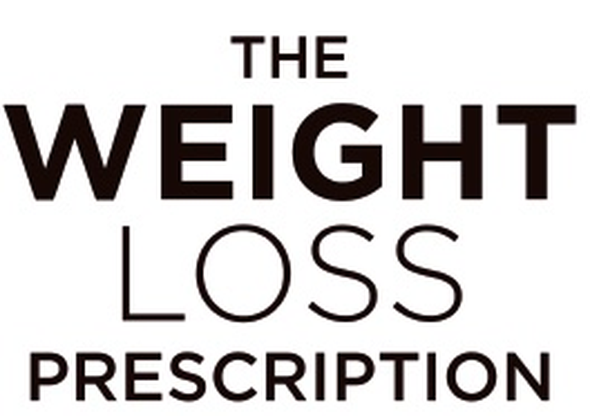
SESSION 5 | Body Image and Weight Loss
Sources of Self-Worth
This exercise helps you understand how much of your sense of value comes from different areas of your life. When your worth comes from multiple sources, a bad body image day can’t destroy your entire sense of self.
What Determines Your Value?
When you think about your value as a person, how much is determined by each of these? Rate each from 1 (not at all) to 5 (very much):

Source of Self-Worth | Rating (1-5)
Work/career success
Relationships and how you treat others
Family roles and responsibilities
Skills, talents and interests
Personal qualities (kindness, humour, intelligence)
Achievements and goals
Physical appearance/weight
What you ate today
Whether you exercised

Key insight: If appearance is everything, you’re vulnerable to constant emotional upheaval. But when your worth comes from multiple sources – your kindness, your work, your relationships, your talents – a bad body image day can’t destroy your entire sense of self.

The Big Question
If you couldn’t change anything about your body for the next year, what else would give your life meaning and value?
What patterns do you notice?
Looking at your ratings, how much of your self-worth depends on appearance vs other sources? What would you like to change?

