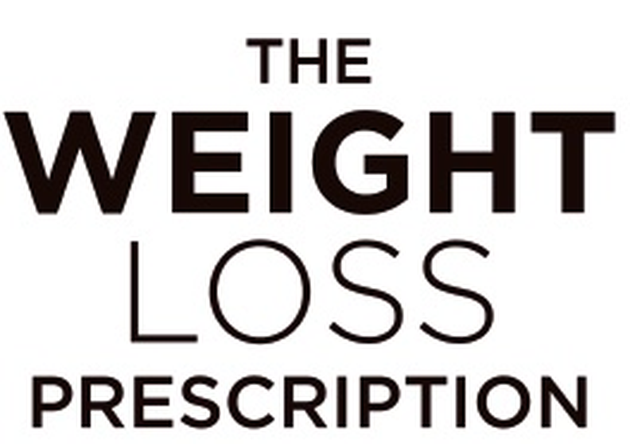
SESSION 5 | Body Image and Weight Loss
Body Image Reflection
Take a moment to honestly assess your relationship with your body right now. Find a quiet space where you can reflect without interruption. There are no right or wrong answers – this is simply information about your starting point.
Immediate Thoughts
When you think about your body, what comes to mind first? List your immediate thoughts – positive, negative or neutral:
1. _________________________________________________________________________
2. _________________________________________________________________________
3. _________________________________________________________________________
4. _________________________________________________________________________
5. _________________________________________________________________________

Looking at your list, how many thoughts were about:
How your body looks: _____ What your body can (or can’t) do: _____ Health concerns: _____ What others think: _____
Body Parts
Which parts of your body do you:
Actively dislike or wish were different:
Feel neutral or indifferent about:
Actually like or appreciate:
If the ‘like’ list was difficult or empty, you’re not alone. People with poor body image often can’t identify anything they appreciate, while those with healthy body image can usually list several things easily.
Mental Energy Assessment
How much mental energy do you spend thinking about your body each day?
☐ Constantly – it dominates my thoughts
☐ Frequently – multiple times throughout the day
☐ Sometimes – a few times a day
☐ Rarely – only in specific situations
☐ Almost never – it’s not something I think about much

