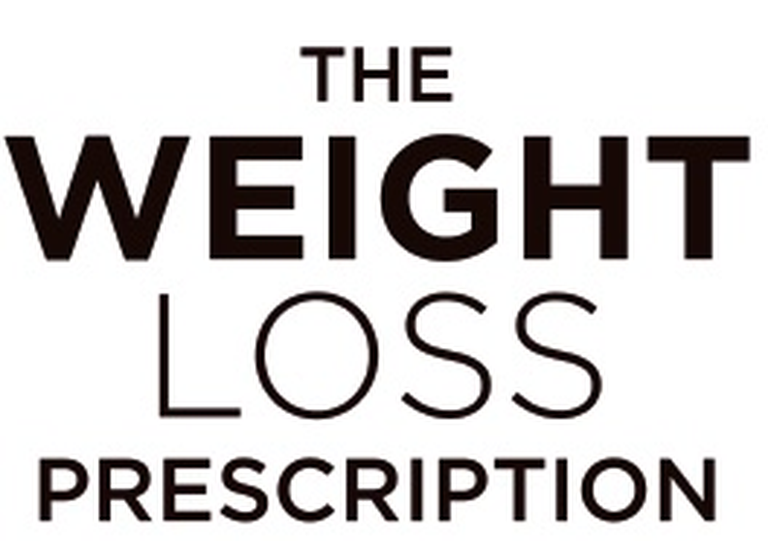
PART 1 | Before You Begin
Success Beyond the Scales

Remember: Weight is just one measure of progress. Rate each marker from 1 (very poor) to 10 (excellent).

Success Marker | Now | Goal
Energy levels throughout the day | /10 | /10
Quality of sleep | /10 | /10
Physical fitness and stamina | /10 | /10
Confidence in social situations | /10 | /10
Relationship with food | /10 | /10
Mental clarity and focus | /10 | /10
Clothing fit and comfort | /10 | /10
Overall mood and wellbeing | /10 | /10
Ability to do activities I enjoy | /10 | /10
Self-compassion and body acceptance | /10 | /10

My Top 3 Non-Scale Goals

